# PL-900: Microsoft Power Platform Fundamentals

1. Power Apps Learning Path:

<https://learn.microsoft.com/en-us/training/paths/create-powerapps/>

<https://learn.microsoft.com/en-us/training/paths/create-app-models-business-processes/>

1. Power Automate Learning Path:

<https://learn.microsoft.com/en-us/training/paths/automate-process-using-flow/>

<https://learn.microsoft.com/en-us/training/paths/pad-get-started/>

1. Power BI Learning Path

<https://learn.microsoft.com/en-us/training/paths/create-use-analytics-reports-power-bi/>

1. Power Pages Learning Path

<https://learn.microsoft.com/en-us/training/paths/power-pages-get-started/>

1. Power Virtual Agents Learning Path

<https://learn.microsoft.com/en-us/training/paths/work-power-virtual-agents/>

Power Apps

**Environment** – can be created from “Setting” -> “Admin Center”, then go to “Environments” on left menu. Click on + sign to create a new environment. Each environment consumes 1GB of space with or without Dataverse.

In environment, you can select “Region”. Select “Type” such as Production, Developer, Trial, Sandbox. Trial environment valid for 30 days and automatically remove after that. To set things up, you should:

1. Create an environment, define environment type
2. Add user to the environment
3. Assign permissions to the added user

**Security Roles** – Predefined security roles such as Environment Admin/Maker or create custom security roles.

**Dataverse** – can store business rules, not just storing the data. Business rules can be things like “trigger” if a record is stored in table or etc.

**Tables** – also called entities or objects. You have default tables and custom tables which can be also imported from unmanaged solutions (include customization created in dev env). These tables in Dataverse follow Common Data Model. Read more at <https://aka.ms/cdmposter>

Read more at <https://learn.microsoft.com/en-us/power-platform/alm/solution-concepts-alm>

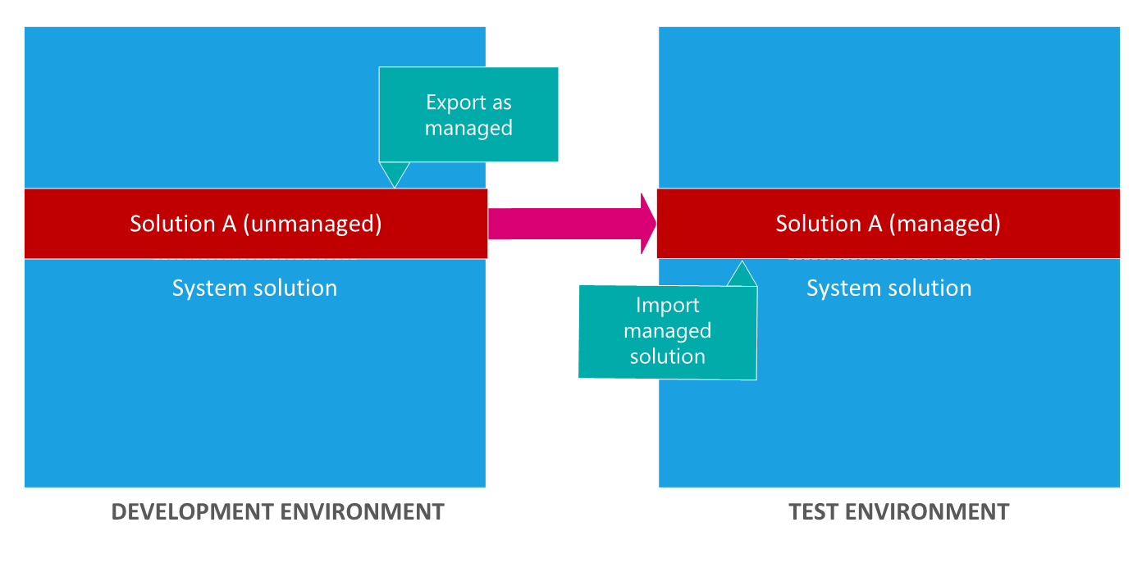

**Unmanaged solutions** are developed and **managed solutions** are deployed. Can’t edit managed solutions directly. If an unmanaged solution is deleted, all customizations will go under default solution and will not be removed. But if the managed solution is deleted, all customizations will be gone.

**Table types** – Standard, Activity (include actions such as Email), Virtual and Elastic

**Row ownership** – two types of row ownerships 1) own by user or team 2) own by organization.

**Table Relationship** – support three types: 1-Many, Many-1, Many-Many.

**Business Rule** – this was applied to Table. Business Rule allow us to add business logic. For example, if the user input value is something, then we can do something to some fields in the table. Some form of validation. Model driven app provides more options for business rule compared to Canvas app. For example, hide/show input based on certain rule is only available in Model driven app. Canvas app still can apply those rules, but it will be more like required/not required, instead of visibility hack.

**Realtime workflow** – workflows are added to the solution. Go to solution and select the solution you want to add workflows. Workflow is located under Automation -> Process. Workflows are attached to tables (entity). Example, before or after a row status change in table, and such situation, we can add “Steps” to perform task. Steps can group into “Stages”. Tips: make sure to uncheck “run in background” if we want the workflow to run real-time.

**Actions** – Like workflow. The difference is action not required to attached to table. Action run based on something happened, such as workflow executed. Action provides messages which we can pass the variables and send to third parties, then process it and return value also can be captured in that action message.

**Dataflow** – allow to create a process. Many connectors to connect the data (such as Excel workbook or online data sources, on-prem resources need data gateway to connect). Useful to create ETL process using this. Example, extracting data from a data sources, transform it and load it back into warehouses.

**More on Dataverse table**

**Views** – each table has many views, and we can customize them, such as adding columns.

**Forms** – to input data into table. There are four different types of forms.

1. Main – you must have it for every table
2. Quick View – provides additional data from the table, e.g., detail view, display data
3. Quick Create – basic form to create new row, input data
4. Card – compact form usable for mobile devices serves same as Quick View

Power Automate

**Instant** – runs on demand on button press from power app or another place. e.g., notification.

**Automated** – runs based on system event, e.g., storing email attachment to One Drive.

**Scheduled** – runs on schedule., e.g., daily reminder email and this reoccurs.

Power Automate use triggers. Power App can be a source to make use of the Power Automate triggers.

IMPORTANT: Power Automate has both Triggers and Actions. But Power App only has Actions (this is because the user using Power App will perform any actions to accomplish the job)

**Trigger** – is an event that starts a flow. This event can be from another system (e.g. new item in SharePoint list).

This page summarizes all the available connectors for Power Automate and Power Apps.

(https://learn.microsoft.com/en-us/connectors/connector-reference/)

**AI Builders** – adding intelligent to apps (without requiring data science skills). Additional licensing required and not include in default Power Platform license. Available for both Power Automate and Power Apps. It uses AI models, either pre-built or custom trained.

# Power BI

Power BI Desktop has three main components.

1. **Data view** – collect/wrangle data. Data can be from multiple sources with different formats. Load these data, inspect, explore and perform data understanding in this view
2. **Model view** – build data model in this view. Tables, columns and relationships are formed here.
3. **Report view** – generate insights using different data visualizations.

Fourth component is **Power BI editor** which can be opened by clicking on “Transform Data” menu.

Power BI Editor: Data Transformation at “Row” Level includes operations such as Use First Row as Header, Use Header as First Row, Filter Rows, Remove Duplicates, Remove Blank Rows, Replace Values.

Power BI Editor: Data Transformation at “Column” Level includes operations such as Remove Columns, Rename Columns, Change Column Types, Split Columns, Custom Columns.

Difference between **Append** and **Merge** – Append is Union, adding more rows to the dataset. Merge is Join, adding more rows and columns (based on specified join key).

**Unpivot** means transform “Columns” to “Rows”

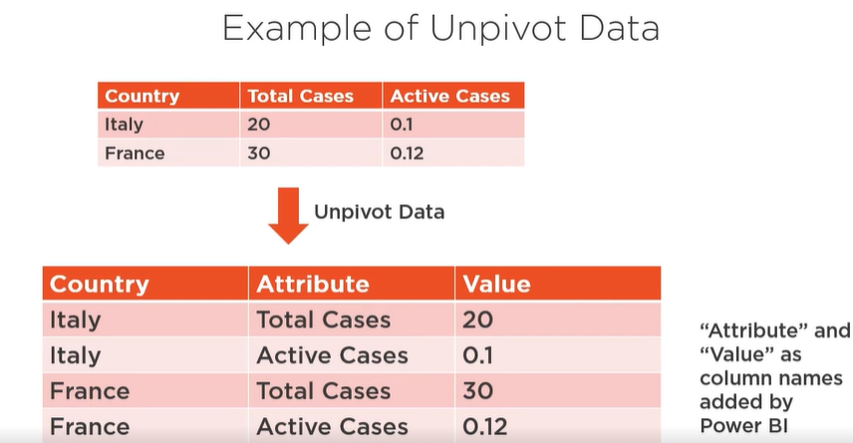

**Pivot** means transform “Rows” to “Columns”.

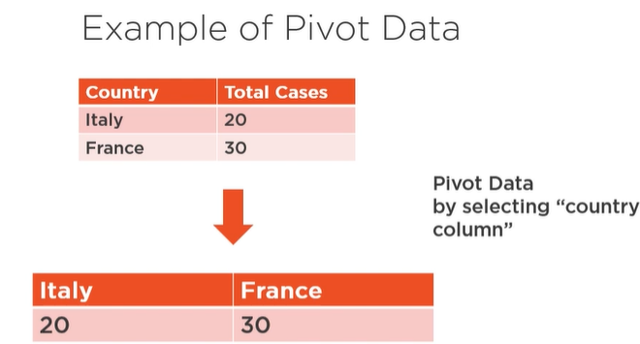

**Visual filters** – three types to pick, “Filter on this visual” apply to current visualization. Other two types are “Filter on this page” and "Filter on all pages”.

**Visual formatting** – two levels, “visualization” and “page”.

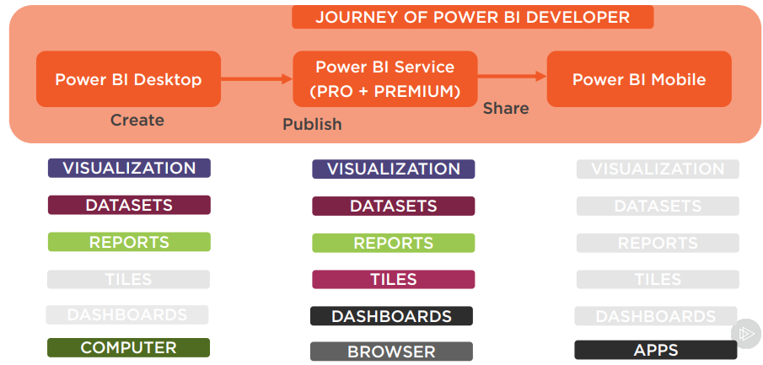

**Tile** - A tile is a snapshot of your data, pinned to the dashboard. You can create tiles from a report, dashboard, the Q&A box, Excel, SQL Server Reporting Services (SSRS) reports, and more. Even you change the type of data visualization from which a tile is created, a tile won’t change its own visualization, only data get refreshed.

**Power BI Data Storage Security** – Dataset uploaded by user is stored on Azure Blob Storage. Metadata of Power BI user is stored on Azure SQL. Power BI user is authenticated using Azure Active Directory.

Workspaces – there are two types, “My Workspace” which is for single user to create and share but not Collaborate, and “Other Workspace” is for multiuser to create, share and collaborate.

# Power Virtual Agents

Create Chatbots. Each bot has one or multiple topics. Can be published to web, MS Teams, Slack, etc.

**Topics** – has **trigger phrases** which allows bot to go to the right conversation **nodes**. There are two types: System topics (built-in, e.g., greetings) and User topics (which we create for our own topics).

**Entities** – represents information that the bot might want to pick out of a conversation, e.g., Places, Products, People. There are prebuilt entities for common information. Can create our own, e.g. Department. We use entities to store our business information.

**Trigger phrases** – These are the phrases that user could use, e.g. What is opening hours?

**Message** – These are the messages that the bot will reply to user based on trigger phrases.

Power Automate

Three types of flows:

|  |  |  |
| --- | --- | --- |
| Cloud flows | Business Process flows | Desktop flows |
| Automation to be triggered either automatically, instantly or via a schedule. | Provide **a guide for user** to get work done. Help users **follow a predefined process** path. | **RPA workflows** that enable to automate process especially useful for legacy app with **no APIs**. |

**Desktop Flow** - Use desktop flows when there is no APIs available. Desktop flows can run attended and unattended. Attended requires Windows user session and it is cheaper (Require Power Automate Premium). Unattended is suitable for high volume tasks and do not require Windows user session. Desktop flow bot can go into remote computer itself and do the job but it licensing is expensive (Power Automate Process).

**Machine-runtime app** – a component required to install if intention is to connect to the Power Automate cloud flow, e.g., cloud flow trigger desktop flow to process some tasks and return the result back to the cloud flow.

**Business Process Flow** – Work well with Model driven apps and Dataverse. Each process is composed of stages and steps to accomplish before moving to next stage. Can include cloud flow to run in desired stages. Can use conditional branching (to skip or include stage) and business rule (show/hide field) in steps.